How to Assign a Jaggaer Approver Delegate
If you are an approver in Jaggaer (this includes all levels of approvers), you may delegate your approval.
- If you plan to be out of the office for less than three months, this document will demonstrate how you may delegate your approval in Jaggaer.
- If you plan to be out of the office for greater than three months, request a permanent Financial Approver Change in Jaggaer under the Jaggaer & Concur Approval Changes section on the Shopping Homepage.
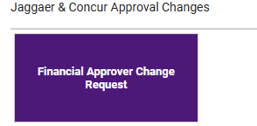

- To assign a delegate in Jaggaer, from the Jaggaer Shopping Homepage, select the Assign Substitute Approvers-Requisitions Quick Link

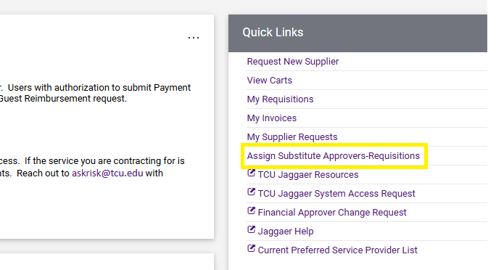
- Identify the Folder Name(s) you want to delegate and select the box on the far-right column. If you want to select all folders, select the box in the gray line.

Example 1 – Selecting specific folder(s). Select Folder(s) and then select Assign
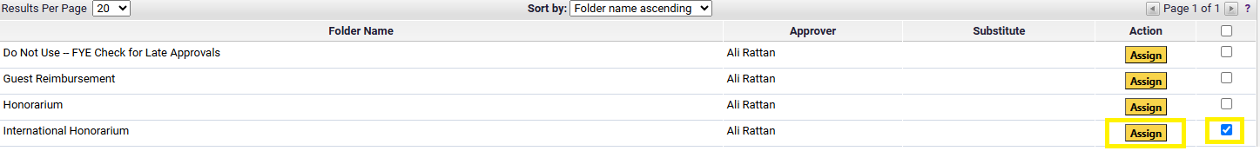
Example 2 – Selecting all folders. Select box in gray line, then select Assign Substitute to All Requisitions Folders.
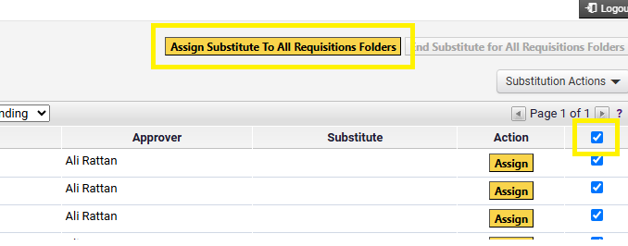

- Assign Substitute. Recommended users include a date range for substitution. Complete the required fields and select Assign.

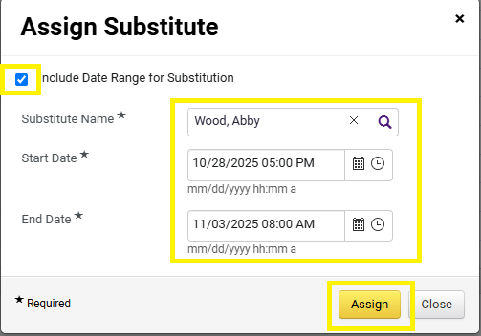

- Users may remove substitutes by selecting Remove from individual folders, or by selecting End Substitute for All Requisitions Folder. Assignments will automatically roll off if users assigned a date range.
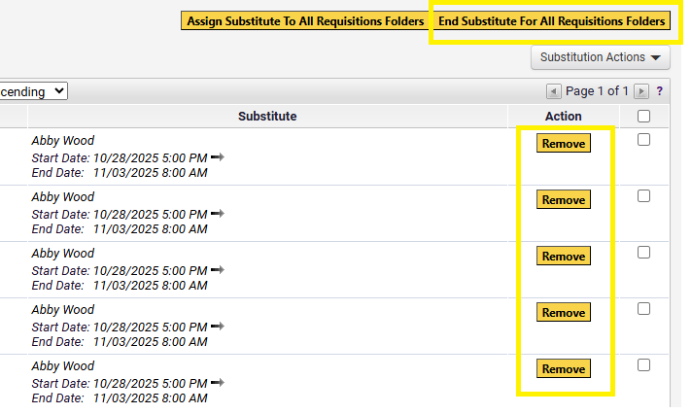
Important Information
- If the person you want to assign as a delegate is not listed when searching, that person does not have the Approver role in Jaggaer, and therefore you cannot delegate your approval to that person.
- Once a delegate is assigned, the delegate will receive approval email notifications for submissions started after they were assigned as a delegate. Delegates will not receive an approval email notification for submissions started prior to delegation, however the submission will be listed under the Action Items of the delegate’s Jaggaer Shopping Homepage and delegates may approve.
- Some users have more than one approver role type (ex-Requisitions and Contracts). To delegate approvals in more than one role, use the dropdown under Type and select applicable types. For each type, assign delegates from the folders listed as needed.

