

**Date:** **XXXXX**

**Prepared by:** **XXXXX**

**Subject: Fleet Size Increase Request**

**Increase Amount**: XXXX

**Vehicle Type**: XXXX

**Funding**: XXXX

**Parking Location:** Lot XXXX (Must include Google map snip with precise parking location – sample below)

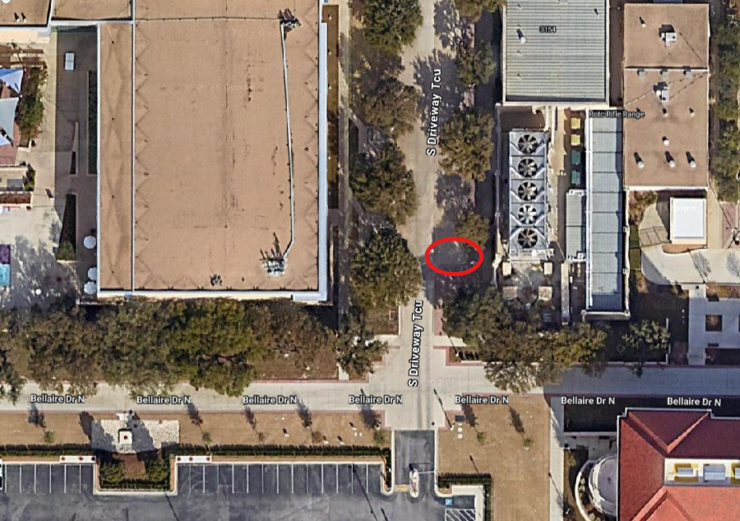

**Current Fleet:**

XXXXXXX

**Justification**:

XXXXXX

**Potential Alternative Solutions to a Fleet Addition:**

XXXXXX

**Additional Notes (if any)**:

XXXXXX