

**Date:** June 28, 2024

**Prepared by:** Rebekah Atkinson, Fleet Manager

**Subject: Fleet Size Increase Request – Athletics/Men’s Golf**

**Increase Amount**: 1 Vehicle

**Vehicle Type**: Full-Size SUV

**Funding**: Men’s Golf Discretionary Fund (Initial Purchase)/ Men’s Golf Discretionary Fund (Future Replacements)

**Parking Location:** Lot 2, 3, or 7

**Current Fleet:**

Men’s Golf currently has no vehicles assigned.

The overall fleet of vehicles for Athletics is as follows (Dealer furnished ‘perk’ vehicles operated by individuals are not included):

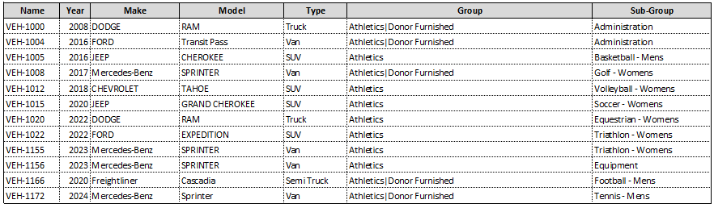

**Justification**:

1. Recruiting

This vehicle would help in recruiting efforts:

* Ability to pick up and drop off recruits from the airport with a TCU-marked vehicle.
* No reliance on rideshare or car service for transportation for the recruit.
* Baylor has a Suburban, and SMU has a Mercedes Sprinter Van.

1. Team Travel:

Men’s Golf practices 5-6 times a week. This would enable the students to carpool to practice. Men’s Golf practices at Colonial CC, Shady Oaks CC, Rockwood CC, Rivercrest CC, Ridglea CC, Mira Vista CC, Leonard’s, and Waterchase CC.

The Men’s Golf team participates in 10 to 12 tournaments each academic year. Of these, 6 to 8 tournaments necessitate airline travel. Typically, one tournament is held in Fort Worth, while the remaining three involve an average round trip of 400 miles.

Currently, Men’s Golf is reimbursing student-athletes to drive their personal vehicles (Approximately $3,600 per academic year).

**Potential Alternative Solutions to a Fleet Addition:**

Athletics investigated the shared use of the Women’s Golf van. Unfortunately, Men’s and Women’s Golf practice at separate off-campus locations based on the availability of the courses. Each program has a different travel schedule for team travel, so it is not feasible for both programs to use the same vehicle. The Women’s Golf vehicle has been paid with donor funds with the donor intent to support the TCU Women’s Golf program only. Additionally, “TCU Women’s Golf” is displayed on their vehicle.

Even in a case where practices are held in the same location, this would not be a viable solution. Men’s and Women’s Tennis practice at the same on-campus location (Bayard H. Friedman Tennis Center). The Men’s and Women’s Tennis head coaches have agreed to share the vehicle. However, Men’s Tennis raised the funds and requisitioned the vehicle for purchase, while Women’s Tennis provided no funding. The Men’s Tennis has the first right of refusal to use the vehicle, so the Men’s Tennis uses the vehicle about 90% of the time. Women’s Tennis uses Fleet Suburbans, rental cars, etc., while Men’s Tennis uses the vehicle.

Men’s Golf occasionally uses the Fleet pool vehicles, but availability is inconsistent/unreliable.

**Additional Funding Notes**:

The approximate cost of the vehicle is $70,000, which is fully funded by the $206,643 in the Men’s Golf Discretionary Fund (62054). The Men’s Golf Head Coach has raised $118K this year as a first-year head coach. He has contacted donors asking for donations specifically for a vehicle purchase, and this request matches the donor's intent.